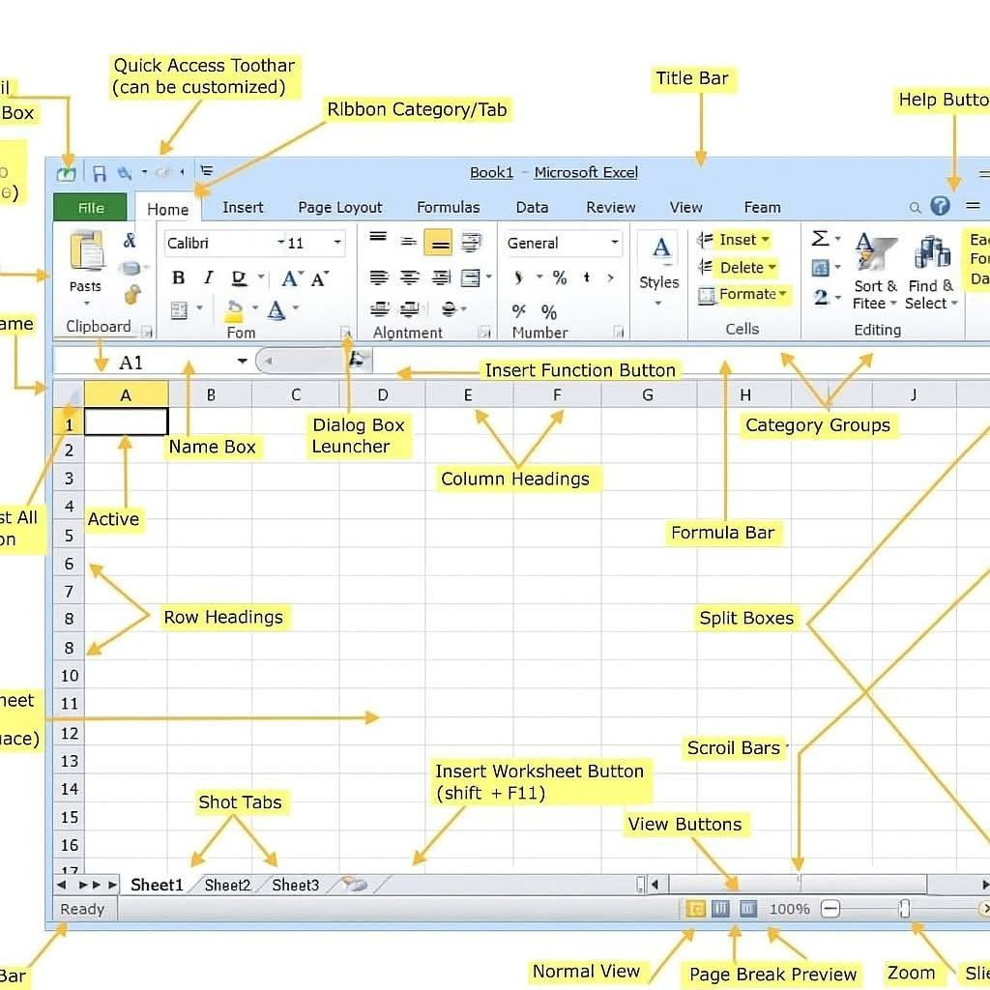
FEATURES OF EXCEL SHEET PROGRAM

